INTERNATIONAL EXCHANGE
TUESDAY

At 7.50 we met in the school in lecture room. Then the Slovenian students made a performance about Idrija.
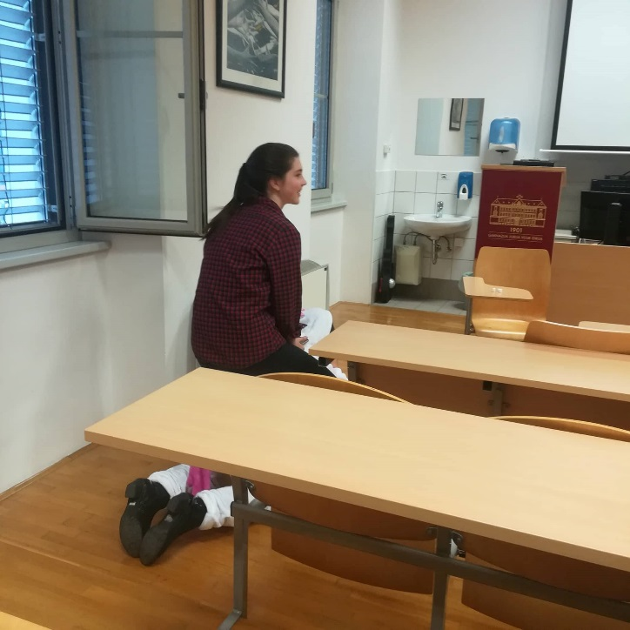

Our headmistress had a welcome speech to Hungarians. After that we joined the Slovene lesson. We learnt a lot of new Slovene words.
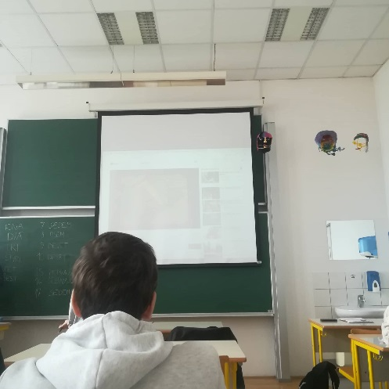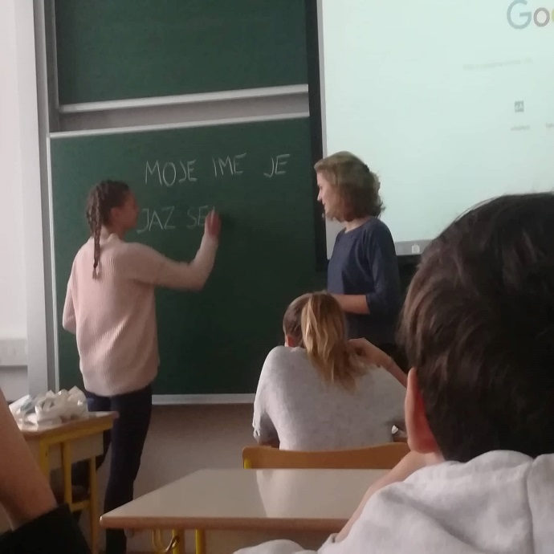

After that we listened to some presentations about the trip to the coast and played quiz.
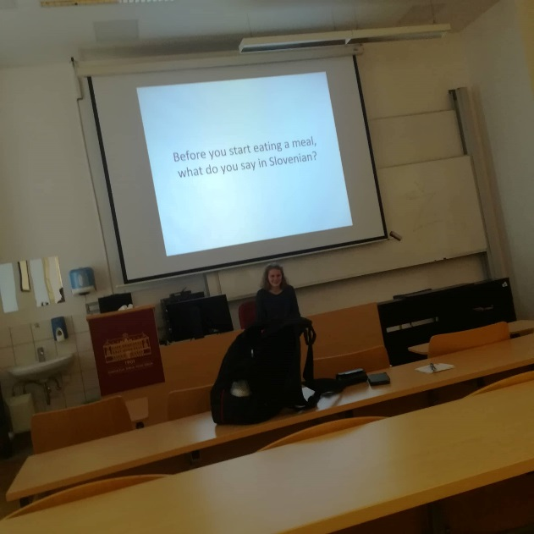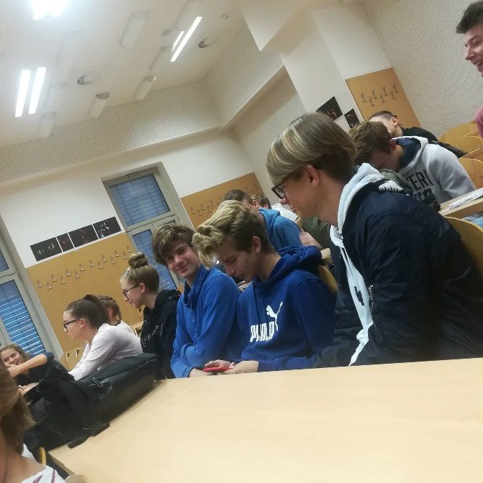

And then we had an orienteering around Idrija. It was really interesting.
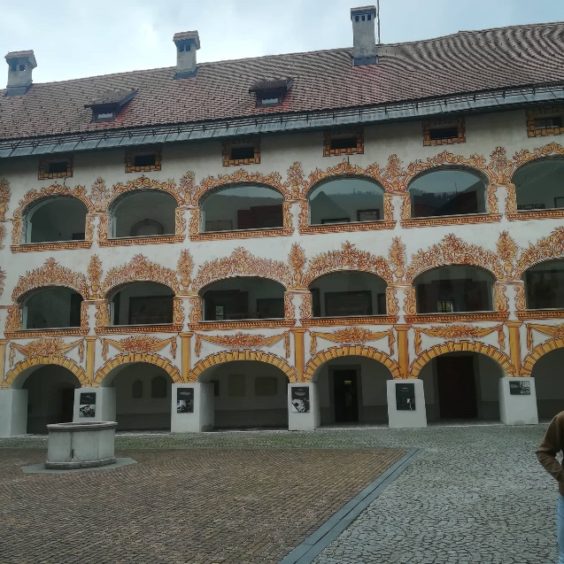

Later the Hungarian students visited Anthony’s main road and our group had lunch in school canteen.
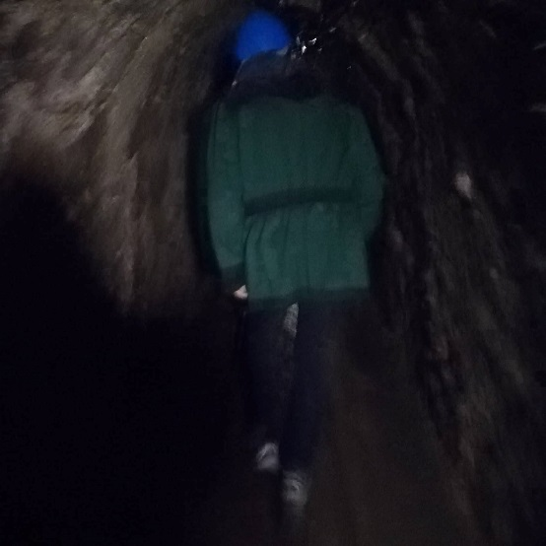

At the end of the day the Slovenian students with their exchange guests went to Hg smelting plant. 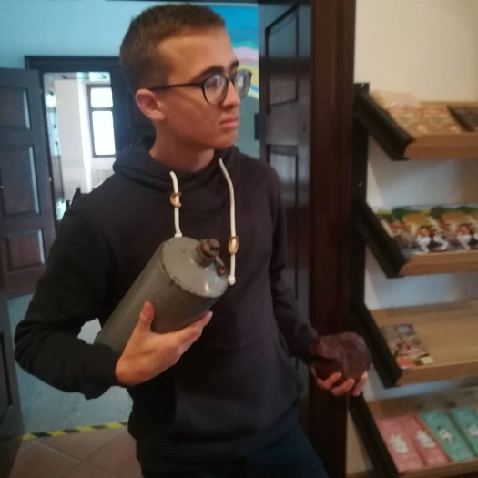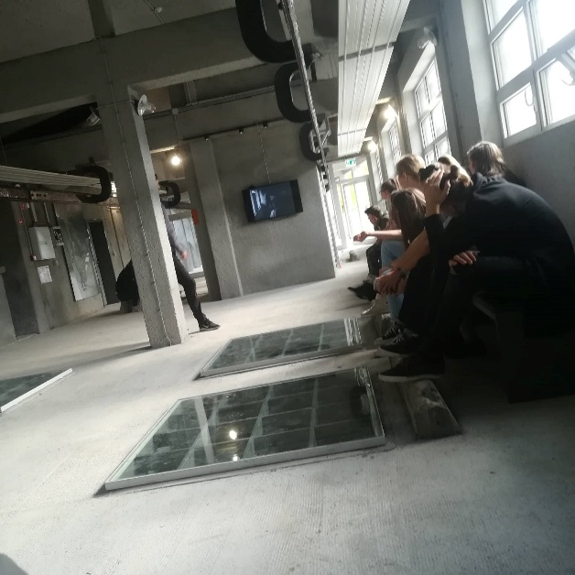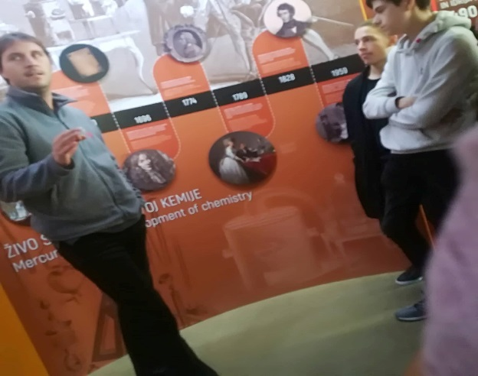

WEDNESDAY
ŠKOCJAN CAVES, PORTOROŽ, PIRAN
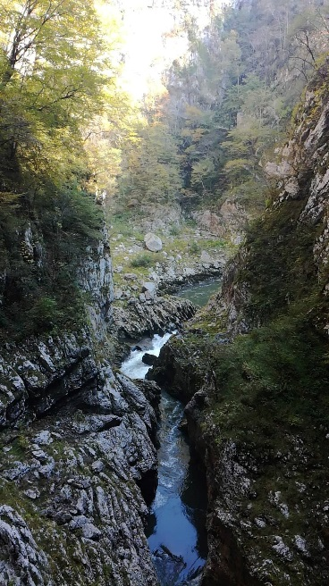
We started our trip at eight when we left from the bus station in Idrija. After an hour or two we arrived to Karst region – to Škocjan caves. We ate delicious food and enjoyed the sun before we entered the cave. We had a nice view to the cave when we entered through the tunnel. Photographing was not allowed so we do not have any photos. There was 12 degrees in the cave but we expected that it would be colder. The guide told us many interesting facts for example that stalagtits grow only a few centimeters in a thousand year. We were walking approximately 2 km through the cave and crossed some high bridges over the river and climbed 500 stairs. We all enjoyed the beauty of the cave and the views.
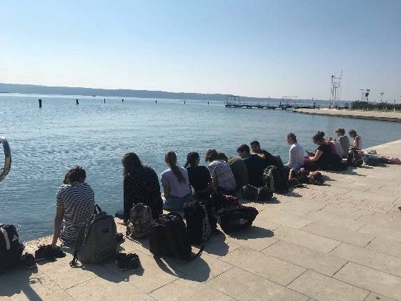
Our next stop was Portorož. We had some free time and most of us just enjoyed the experience with our feet in the sea. It was a perfect day to spend near the sea because it was very warm.

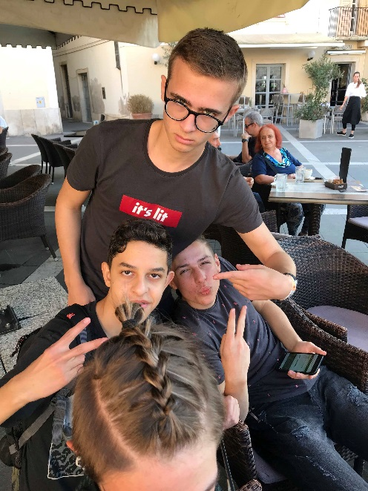
Then we walked to Piran. That took about an hour but it felt like a few minutes since the seaside was breathtaking. When we arrived to the Tartini square we split into two groups. Each group visited the main sights and some girls gave us some details about them. We also had some free time which we spent differently. Some of us were walking on the seashore while eating ice cream, and some of us just took a rest after the exhausting day.
To sum up we really enjoyed ourselves, and were glad to visit some attractions of Slovenia.

Nagybanyai-Nagy Anna, Kiss Kamilla, Zala Serženta Seljak

THURSDAY
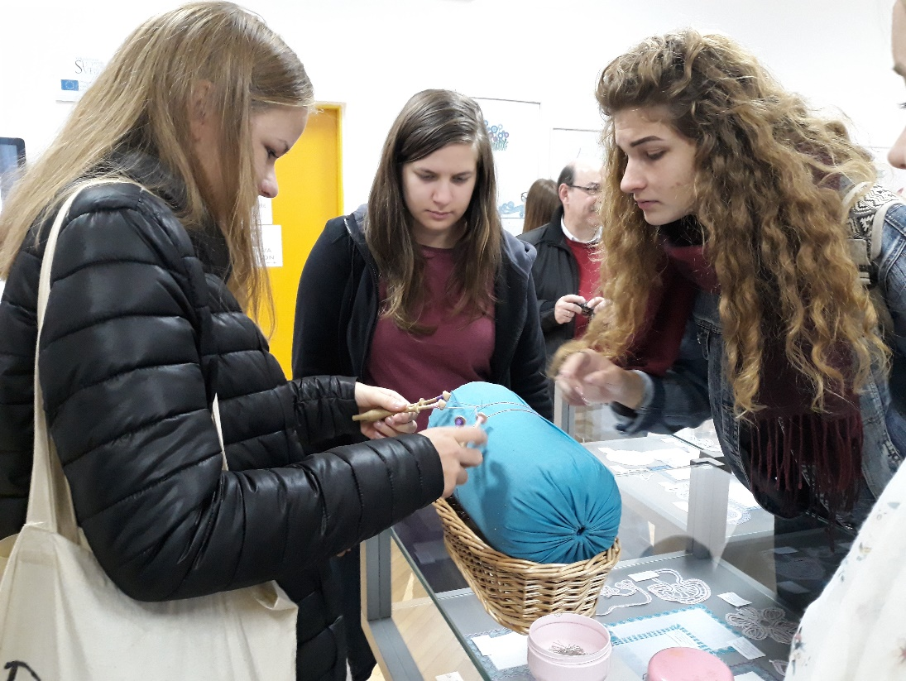
A visit to the exhibition of lace
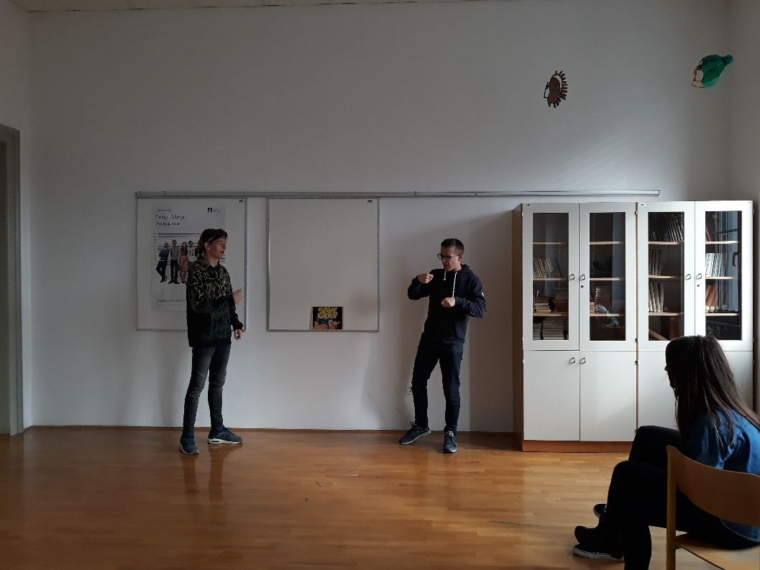
Improvisational theatre workshop
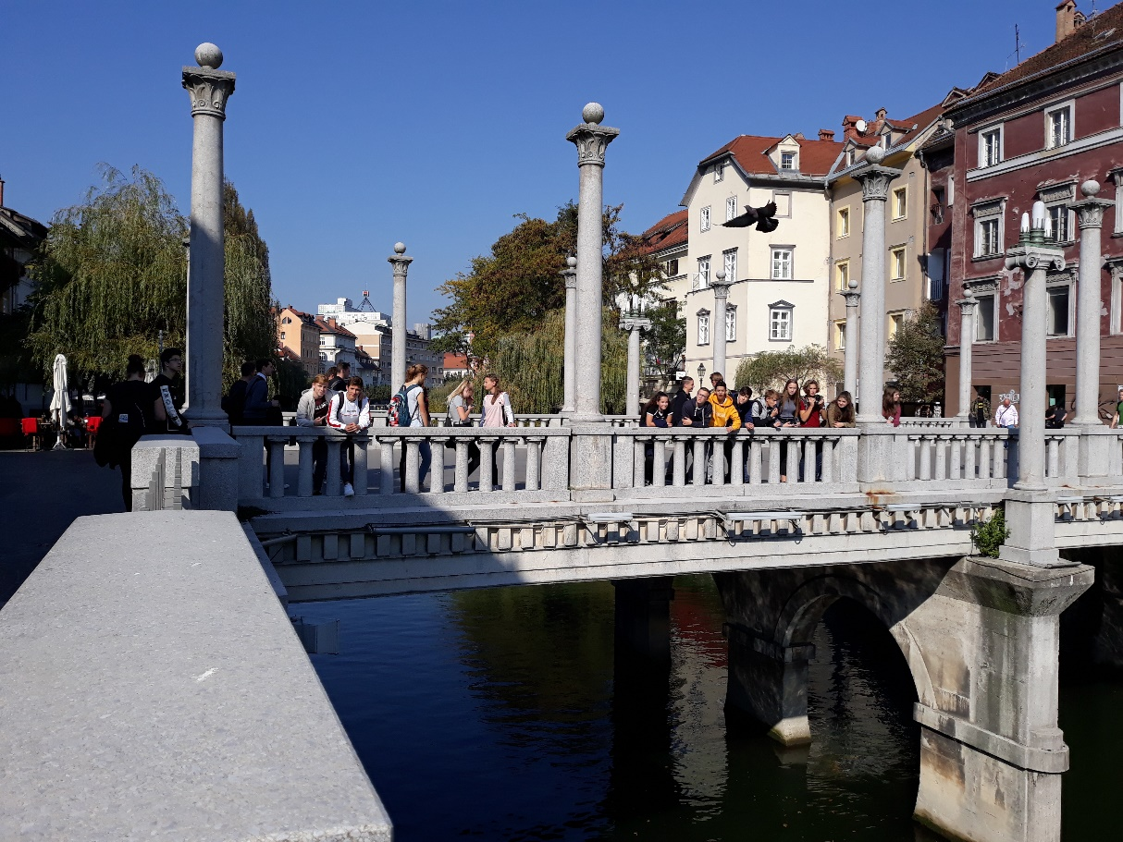
Visiting Ljubljana

FRIDAY
On Friday, 12.10., we came to GJV an hour later because teachers let us sleep another hour. We started Friday's program with presentations of well known Slovenian dishes and desserts. We listened to three students that presented us kranjska klobasa (sausage), prsosciutto and nutt roll. And of course we got a chance to taste them all. After the presentations we stayed in the class, listened to music and had fun. Then the Slovenian students went to their classes and the Hungarians had English and physics class. After that, they went on a walk to the Wild lake. When they came back we had lunch in our school canteen. We spent our afternoon rest on the grass in front of our school where we lay and listened to the sounds of popular music. Later we went to the multimedia class where we prepared presentations, articles and videos of the past week. Then we went home and packed our bags. In the evening we went to the Youth center Idrija, where we spent the night on the terrace with good music and food. The next day we said goodbye and cried together because the Hungarian students went home.
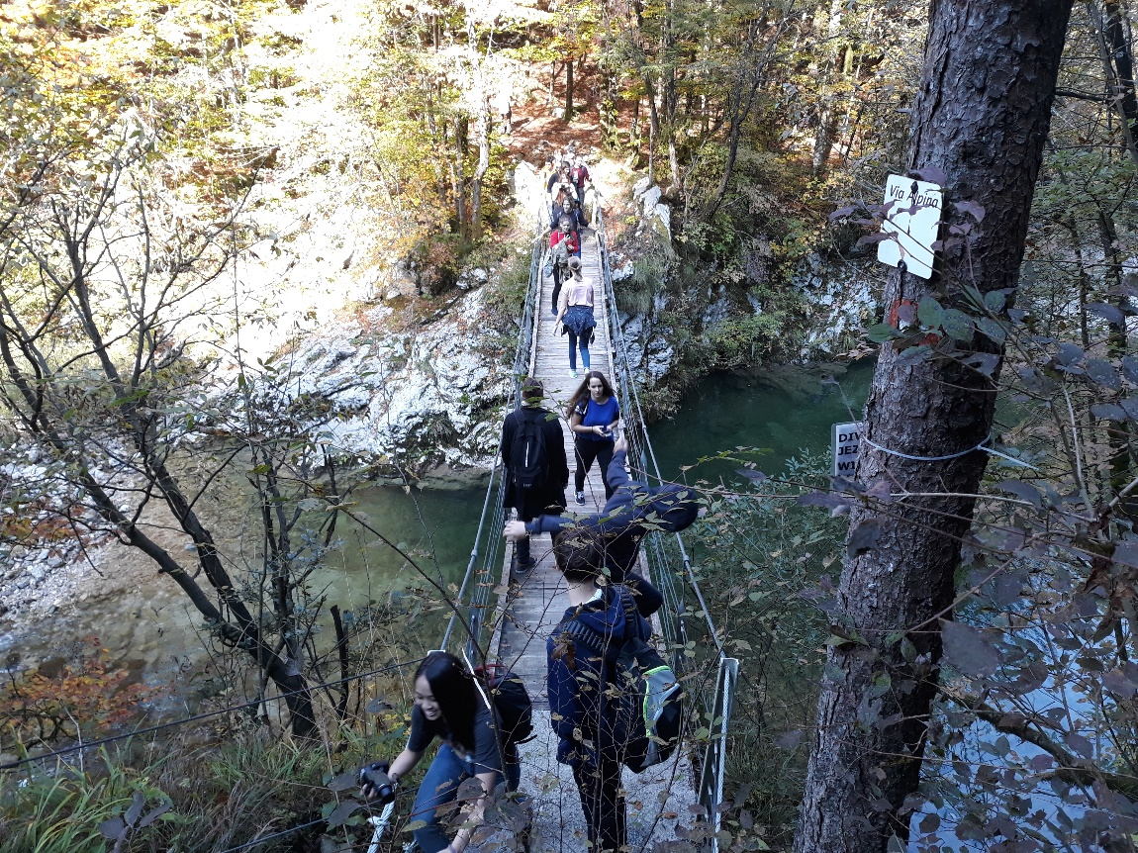
Suspension bridge on the way to the Wild Lake
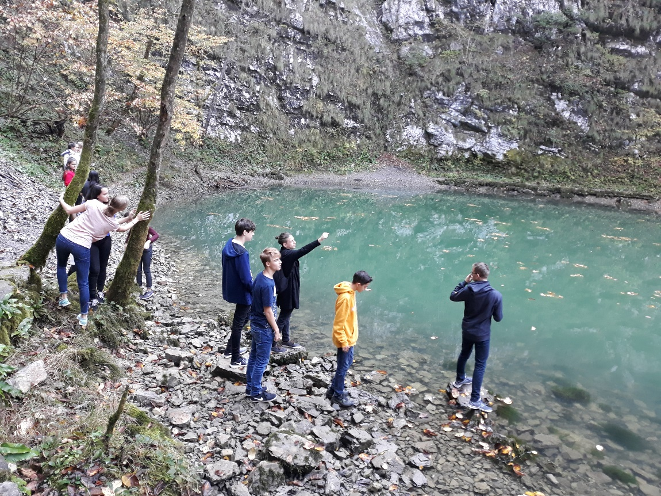
The Wild Lake
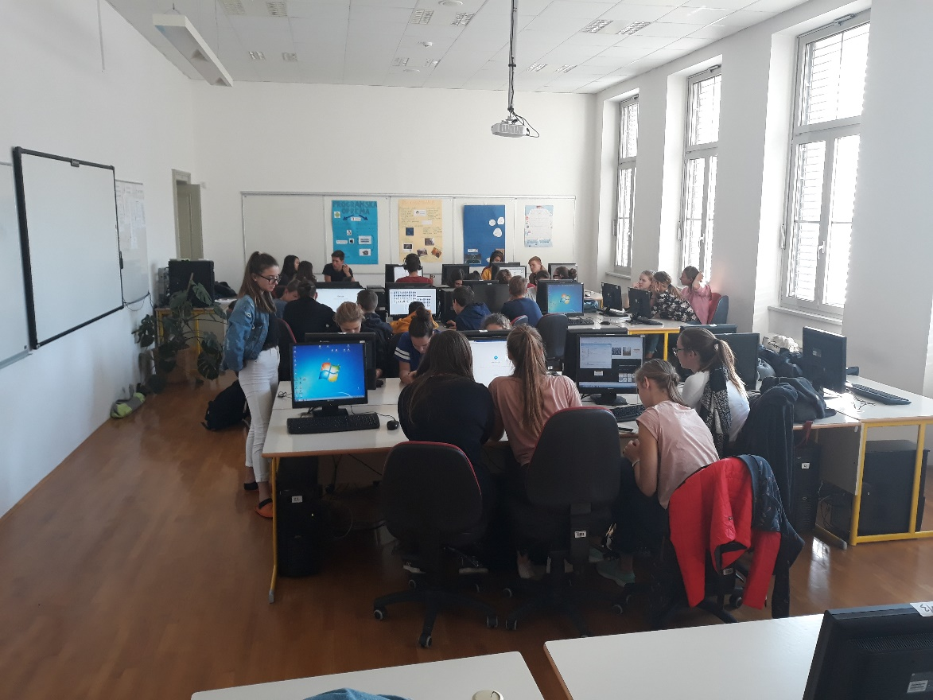
Making videos, power points and documents about the exchange

