SLOVENIA vs. HUNGARY

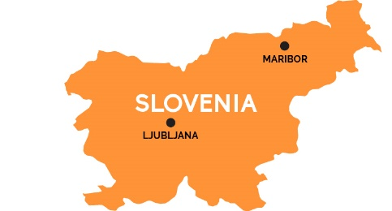

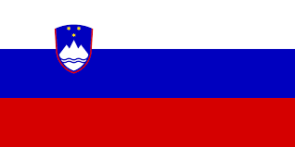

POPULATION
2 ,000, 000 10, 000 ,000

ORIGIN OF THE LANGUAGE
Slavic Ugrofin

GRAMMAR
Singular, DUAL, plural Singular, plural

LANDSCAPE

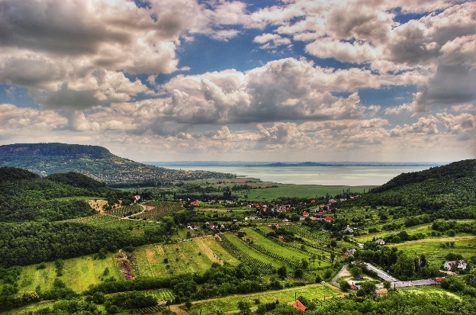
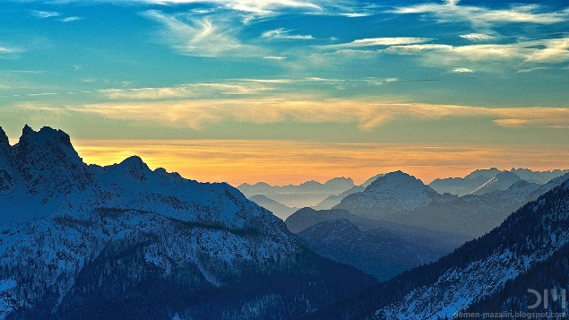

BIGGEST LAKES
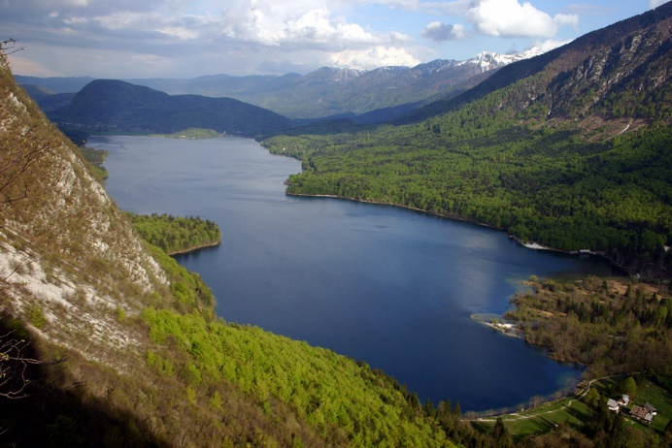
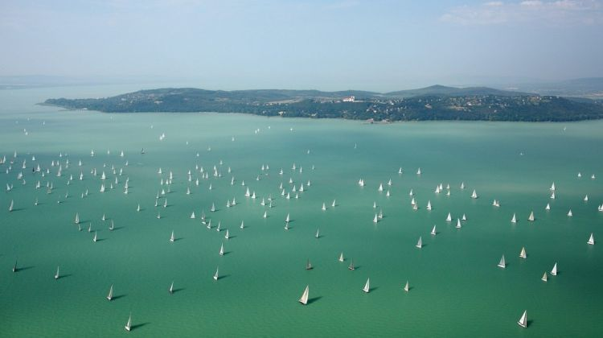

Written by Laszlo Balazs, Reka Bornemissza, Lucija Kalan Bevk and Zala Kopač

JURIJ VEGA GRAMMAR SCHOOL and EÖTVÖS JÓZSEF GIMNÁZIUM
Jurij Vega Grammar School
-students must wear slippers
-5-min breaks
-students can leave school during the breaks
-350 students
- a gym
-extra curricular activities (playgroup, newspaper, radio)
- sport weeks + one-day excursions
-locked classrooms
-lockers only in locker room

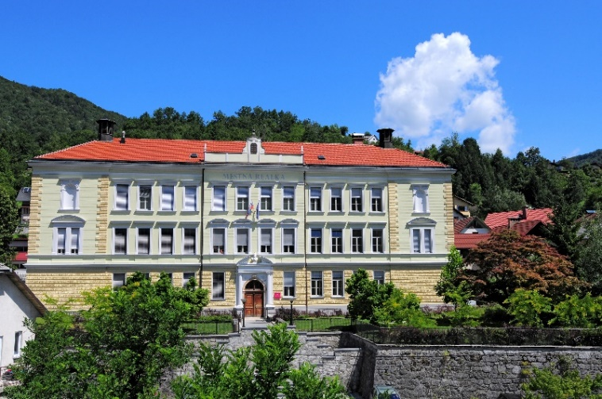

Eotvos Jozsef Gimnazium
-students can wear shoes
-15-min breaks
-students can’t leave school during the breaks
-850 students
-gym + weightlifting
- extra curricular activities (playgroup, newspaper, radio + choir. etc)
-summer/Ski/cultural/History camps + one day excursions
-most classrooms are unlocked
-lockers all around the school (2 people per locker)
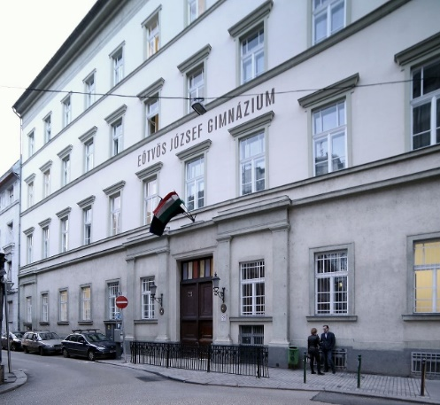
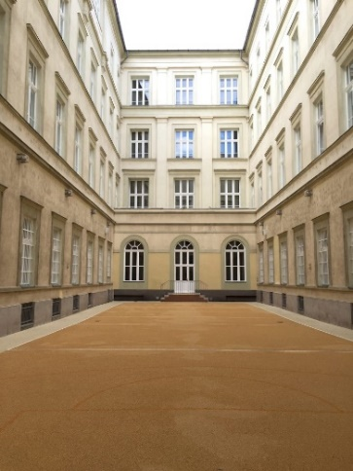
Written by: Bank Kozma, Melinda Dombora, Eva Rot, Ana Govekar, Domen Makuc

TUESDAY, 1 October 2019
First we had the presentations in about Slovenia, Idrija and Jurij Vega Grammar School.
After the presentations the exchange students attended Slovene lesson that was led by Tjaša and Alja. They said they really enjoyed it but that they didn’t remember much. They are very happy that they know how to present themselves in Slovenian.
At 11.00 we visited the Anthony’s Main Road, it was very cold and we were very happy that we could wear helmets and the jackets. The guide was very interesting and kind of upset because we didn’t respect the souls of the fallen miners.
After we came back to school we ate lunch and we really liked it. It was delicious.
At 13.45 we all went to the gym and played games that connected us and we had a lot of fun. We really liked the game where we drew each other. The masterpieces at the end were amazing and breath-taking.
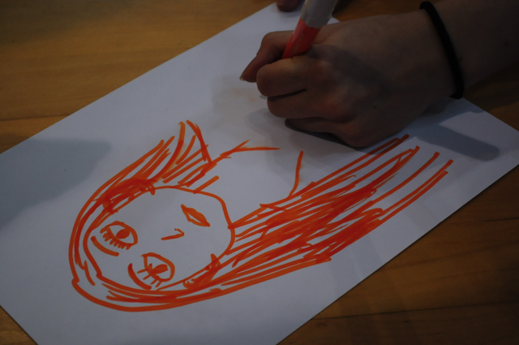

After the games we had orienteering in Idrija so we split into groups of four and explored the beautiful town in Slovenia. We had a lot of fun and we learned how to read maps. We had to do a lot of interesting challenges and we learned a lot of things about Idrija. We tried our knowledge in a game of Kahoot after that.
We went home tired and slept well.
Written by: Flora Raj, Dorka Devecz, Teja Jurca, Tereza Hladnik and Živa Božič Lapanja

THURSDAY, 3 October 2019
We started the day with a lace exhibition. There was a lot of different shaped and coloured lace. The teacher told us various information that was never heard before. After that we joined the workshops. The members of the group were separated into 4 different parts: dancing, improvisation, cooking and lacemaking.
According to Gregoro the improvisation was the best choice due to the magnificent atmosphere in the classroom.
Anna briefly told us that lacemaking made her soul calm because of the precise handwork that’s required to make the lace precious. “It was nice to make lace after a long time” – that’s what Teja told us.
After an exhausting conversation, we found that Norba wants to become a chef after he tried cooking žlikrofi. Pia doesn’t want to become a chef because she is already a master chef.
And there was also dancing, but sadly nobody experienced the tremendous fun that traditional Slovenian dance choreographs give us.
In the next part of the day we ate žlikrofi, which was delicious.
After that, we visited Ljubljana. “The tires of the bus were in perfect condition” – Zola told us, after he longingly checked the tire pressure. We had the enormously charming opportunity to be Gal’s guest at the HIT WOK Asian Restaurant. Interesting topics emerged during our eating process, such as finding out who is the dominant alpha male in the group. Then we went home. That was it. “Oh, and there was a castle, too. And a street“ – Said Anna. Good job Anna!
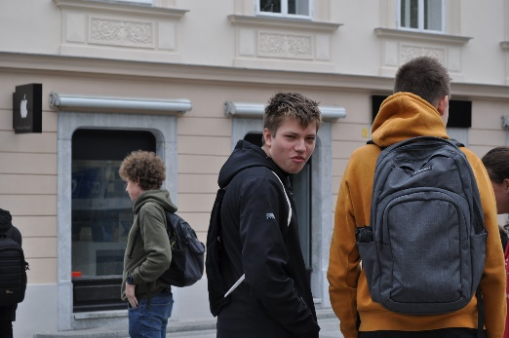
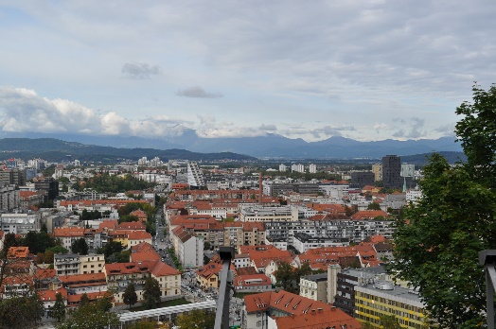
Thank you for your time and assistance. The Hungarian people are looking forward to visiting you again.

Written by: Gergő Marton, Anna Ballai, Norbert Csipai, Pia Bogataj and Teja Tušar

FRIDAY, 4 OCTOBER 2019
On Friday we first attended two lessons with the Slovenian students. Some of the lessons that we attended were biology, maths, English, physics and chemistry. We had fun!
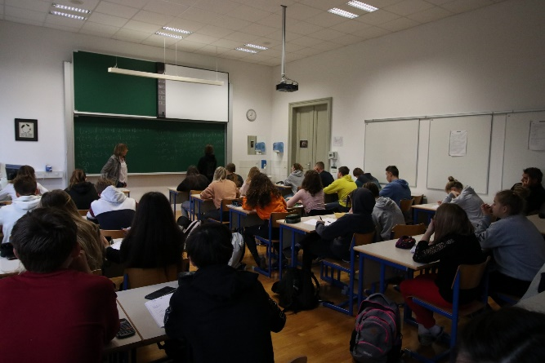
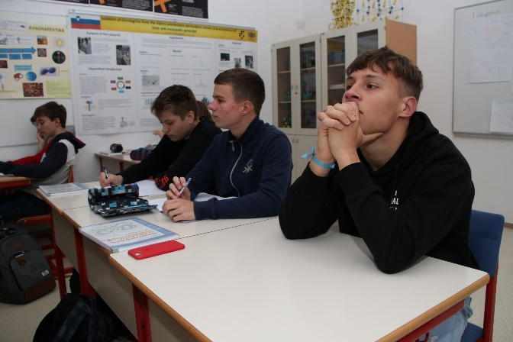
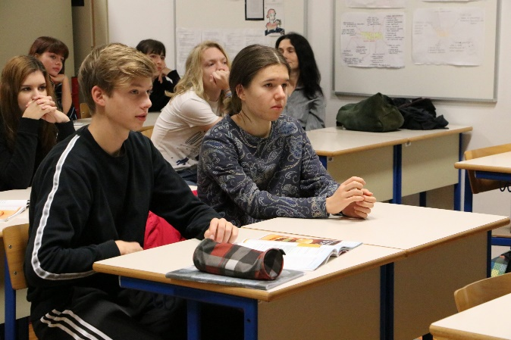

Then we had presentations of traditional Slovenian dishes and we tasted them as well. They were delicious!
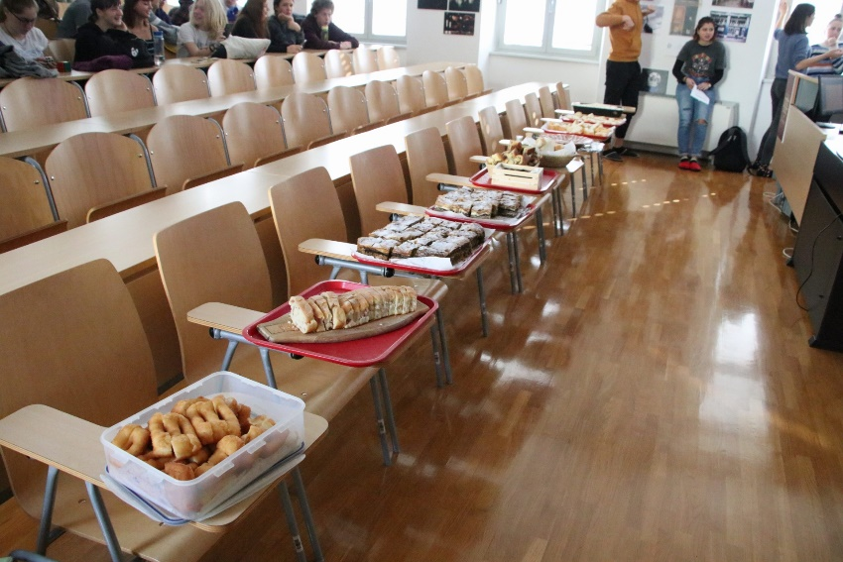

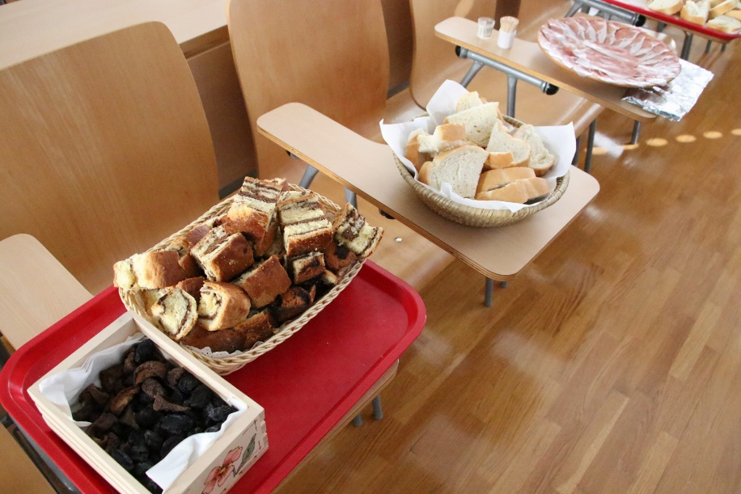

Our next destination was the mercury smelting plant. It was very interesting ;-)
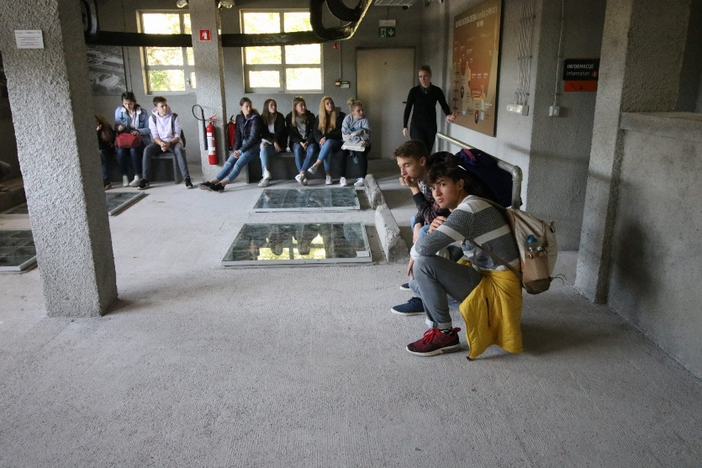

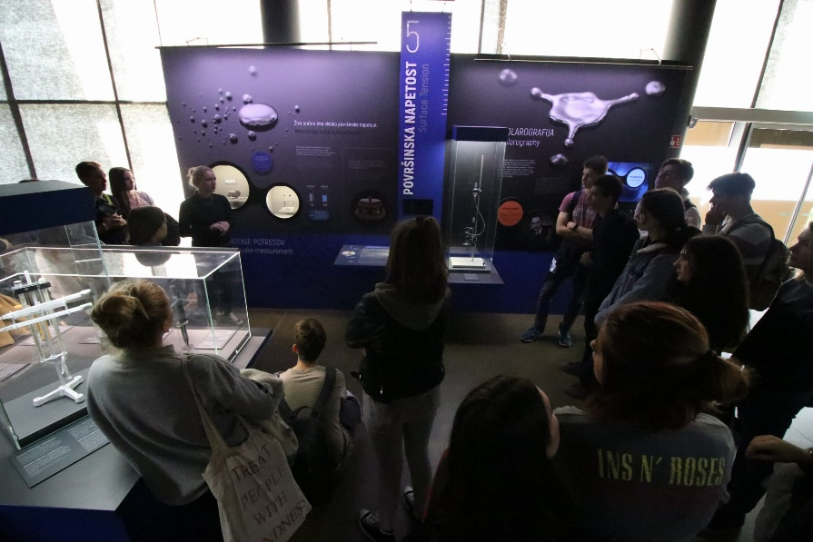

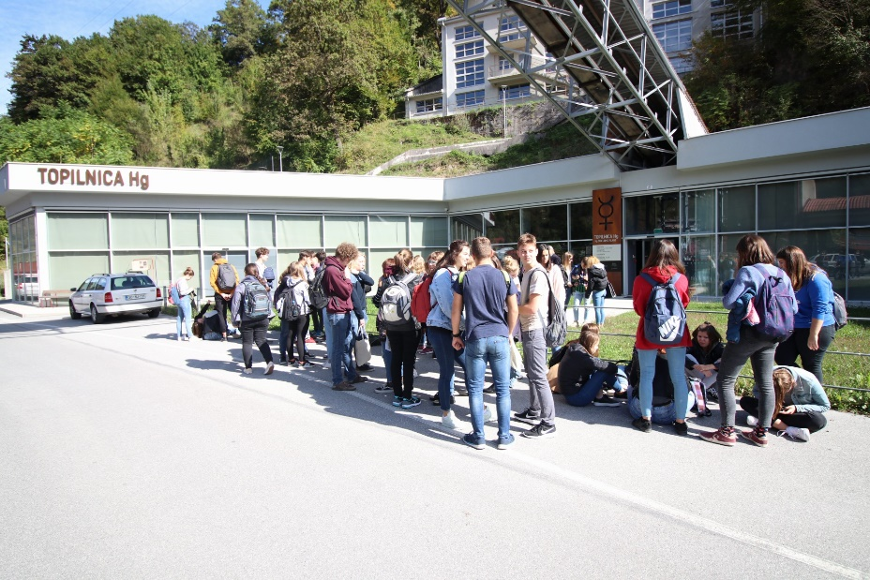

Written by: Daniel Gonda, Rozi Laszlo, Fanni Palyov, Jaka Vidmar, Sara Rupnik

SLOVENIAN CUISINE
We tried 9 different dishes and all of them were really good. We ate potica, žlikrofi, kremšnite, pršut, zeljševka, prekmursko gibanico, ocvirkovico in flancati.
My opinion about potica is that it was okay. It was similar to kuglof. Zlikrofi was easy to make and it tasted good. Kremšnite was exactly like francia kremes. Pršut was good. We liked it because it was homemade. All the other food was good, too.
The school food in Hungary is worse than ours. We will make žlikrofi at home when we arrive. In this week we had really good food at our hosts too and it was pretty much the same as ours in Hungary.
Written by: Tinkara Pavsic, Klara Istenic, Baka Zoltan, Müller Barnabas
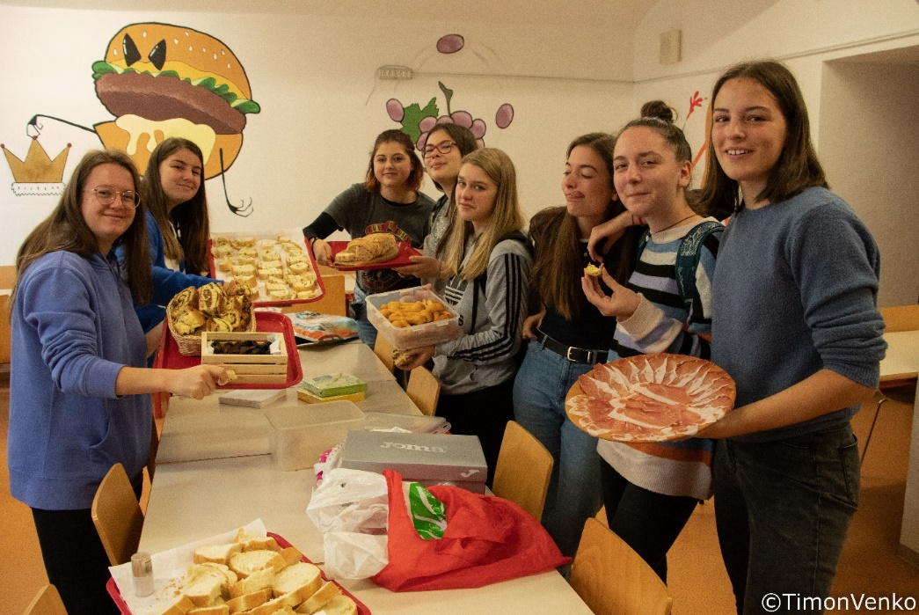
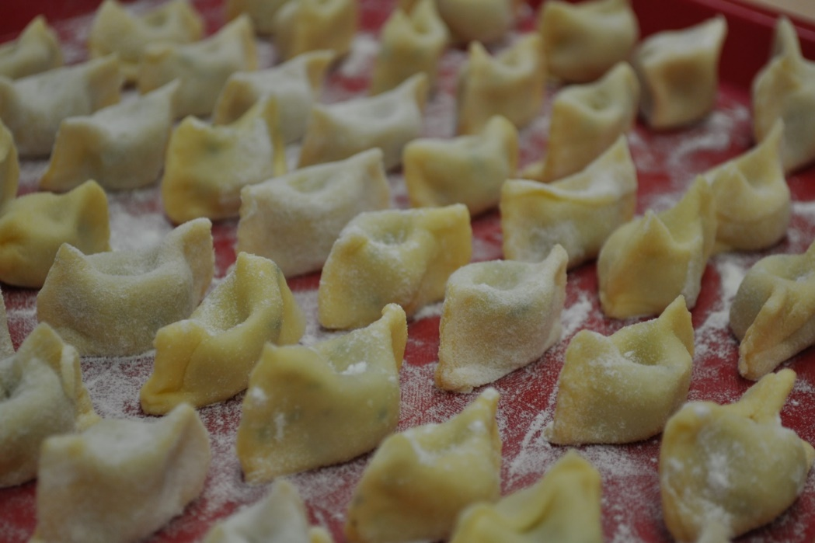

SIMILAR WORDS IN SLOVENIAN AND HUNGARIAN
During the exchange we realized that there are a lot of similar words in Slovenian Hungarian. Here are some:

Kača – snake kacsa – duck
Bela – white Béla – male name
Čaj – tea csaj – slang expression for a girl
Mačka – cat macska – cat
Kompot – compote kompót – compote
Čipka – lace csipke – lace
Četrtek – Thursday csütörtök – Thursday
Petek – Friday péntek – Friday
Sobota – Saturday szombat – Saturday
Sreda – Wednesday szerda – Wednesday
Jelen – deer jelen – present (not past)
Pia – girl's name pia – slang expression for alcohol
Teja – girl's name tea – tea
Palačinka – pancakes palacsinta – pancakes
Soba – room szoba – room
Virus – virus vírus – virus
Bomba – bomb bomba – bomb
Cirkus – circus cirkusz – circus

Written by: Lili Solyom, Vivien Szauer and Klara Martinšek

HABITS IN OUR HOMES
We figured out that Hungarian people are not used to having lunch with the whole family, they only have lunch with the whole family once a week. Even in Slovenia it depends on each family. The Hungarians pointed out that they are not used to drinking juice at lunch, that they mostly drink water. A lot of us drink juice at lunch but we find it even more interesting that Slovenian people mix juice with water and that is the thing that the Hungarians do not do. As hosts we noticed that our guests took a lot of time for eating and showering, which differs from us , because we are always in a hurry.
Written by Tonja Hladnik, Laura Rudolf, Dora Szijarto, Eszter Torgyik, Soma Breitner

